PROBLEM STATEMENT-01
students = ["Arun", "Bala", "Karthik"]
students.append("Elan")
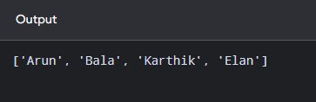
print(students)

